**<TITLE OF PROJEC>**



**THESIS SUBMITTED TOWARDS THE PARTIAL FULFILMENT OF THE REQUIREMENT OF THE UNIVERSITY OF SINDH, FOR THE AWARD OF BACHELOR OF SCIENCE IN SOFTWARE ENGINEERING**

**SUBMITTED BY**

**<FULL NAME> <Full Roll Number>**

**<FULL NAME> <Full Roll Number>**

**<FULL NAME> <Full Roll Number>**

**SUPERVISOR**Ms. Nazish Basir  
Assistant Professor

Department of Information Technology

**CO-SUPERVISOR**Title FirstName LastName  
Designation

Department of <Department Name>

**DEPARTMENT OF SOFTWARE ENGINEERING**

**FACULTY OF ENGINEERING AND TECHNOLOGY**

**UNIVERSITY OF SINDH**

**Session 2023**

# certificate

**TITLE OF PROJECT**

**A Thesis Submitted By**

**<FULL NAME> <Full Roll Number>**

**<FULL NAME> <Full Roll Number>**

**<FULL NAME> <Full Roll Number>**

|  |  |
| --- | --- |
| **______________________________** | **______________________________** |
| **Supervisor’s name and signature** |  |
|  |  |
|  |  |
|  |  |
|  |  |
|  |  |
| **______________________________** | **______________________________** |
| **Co-Supervisor’s name and signature** |  |
|  |  |
|  |  |
|  |  |
|  |  |
|  |  |
| **______________________________** | **______________________________** |
| **Coordinator Final Year Projects** |  |
|  |  |
|  |  |
|  |  |
|  |  |
|  |  |
| ______________________________ | ______________________________ |
| **Chairman**  **Department of Software Engineering** |  |

# ACKNOWLEDGEMENTS

We are thankful with the core of our heart to almighty allah. Lord of the universe, who made it possible to complete our project report successfully. The success of a project depends on the contributions and supports of many people whom we would like to appreciate for their support in the duration of this project. We would like to express our gratitude to our supervisor Nazish Basir who is responsible for supervising and monitoring our progress of this project thesis. Secondly our friend for offering their guidance and encouragement to us. Otherwise, this project would not have been possible to be developed properly.

Our special appreciation and thanks to our family who always stands by us no matter what happens. Their full support and encouragement were such a boost for our capabilities and confidence to undergo this period last but certainly not least, we also want to thank all our friends for their invaluable assistances towards this project thesis.

Special thanks to everyone who involve in this project either direct or indirectly. We must admit here that it was impossible for us to completing our project thesis without the supports of them that we mentioned above.

# ABSTRACT

Students and teachers have been facing problem due to the absence of centralized web service for the department. This project solves their problem in the form of providing DYNAMIC INTERFACE OF MEDIA AND COMMMUNICATION which gives them ready access to information and centralized system for assignments, timetable, notes and results.

DYNAMIC INTERFACE OF MEDIA AND COMMMUNICATION is design for the purpose to ease the communication between Teachers and Students. There are different kinds of users that have different roles on this portal. The major users are students and Teachers which take the most advantage of this website. Once a teacher and student are registered, they will receive benefits from this website. This project will also help in collaborative learning.

On the other hand, administrator of the website is able to centralize the information between students and teachers. He/she can access to every part of the website and have right to edit, delete, change, upload, making reports and supervise the system. It will reduce the burden of collection, organization, management and sharing of notes, assignments, and announcement of exam timetable, results and event notifications which are being maintained manually by the faculty.

# List of Figures

Figure 1‑1: Context Diagram of Application 3

Figure 3‑1: Use Case Diagram of Teacher 11

Figure 3‑2: Use Case Diagram of Student 12

Figure 3‑3: Use Case Diagram of Admin 13

Figure 3‑4: Activity diagram of Teacher 14

Figure 3‑5: Activity diagram of Student 15

Figure 3‑6: Activity Diagram for Admin 16

Figure 3‑7: Entity Relationship Diagram 17

Figure 3‑8: System Architecture 18

Figure 5‑1: Login of Admin 27

Figure 5‑2: Admin Panel 28

Figure 5‑3: Teacher Login 29

Figure 5‑4: Lecture Upload by teacher 30

Figure 5‑5: Enquiry Checked by Teacher 31

Figure 5‑6: Student Registration 32

Figure 5‑7: Student Login 33

Figure 5‑8: Main Page 34

Figure 5‑9: Enquiry Send By Student 35

Figure 5‑10: Enquiry Check By Admin 36

Figure 5‑11: Time Table Upload By Admin 37

Figure 5‑12: Time Table Display at Main Page 38

Figure 5‑13: Result Upload by Admin 39

Figure 5‑14: Result show at Main Page 40

Figure 5‑15: Gallery 41

# Contents

certificate I

ACKNOWLEDGEMENTS II

ABSTRACT III

List of Figures IV

Contents V

Chapter No. 1 INTRODUCTION 8

1.1 BACKGROUND 8

1.2 DEPARTMENT OF MEDIA AND COMMUNICATION 8

1.3 OBJECTIVES 9

1.4 SCOPE 10

Chapter No. 2 Background and Literature Review 11

2.1 THE WEBSITE 11

2.2 HISTORY OF WEBSITE 11

2.3 DYNAMIC WEBSITE 12

2.3.1 AVANTAGES OF DYNAMIC WEBSITE 12

2.4 INTRODUCTION TO RESPONSIVE WEBSITE 12

2.5 WEB CONTENT MANAGEMENT SYSTEM 13

2.5.1 IMPORTANCE OF CMS 13

2.5.2 MAIN FEATURES OF CMS 14

2.6 HIGHLIGHTED FEATURES 14

2.6.1 ADMINISTRATOR FEATURES 14

2.6.2 TEACHERS FEATURES 14

2.6.3 STUDENTS FEATURES 14

2.6.4 AREA OF APPLICATION 15

2.7 ADVANTAGES DYNAMIC INTERCAE OF MEDIA AND COMMUNICATION 15

Chapter No. 3 ANALYSIS & DESIGN 16

3.1 REQUIRMENTS 16

3.1.1 FUNCTIONAL REQUIREMENTS 16

3.1.2 NON-FUNCTIONAL REQUIREMENTS 17

3.2 DESIGN OF MEDIA AND COMMUNICATION WEBSITE 18

3.2.1 USE CASE FOR TEACHERS 18

3.2.2 USE CASE FOR STUDENT 19

3.2.3 USE CASE FOR ADMIN 20

3.2.4 ACTIVITY DIAGRAM FOR TEACHER 21

3.2.5 ACTIVITY DIAGRAM FOR STUDENT 22

3.2.6 ACTIVITY DIAGRAM FOR ADMIN 23

3.3 ENTITY RELATIONSHIP DIAGRAM 24

3.4 SYSTEM ARCHIECTURE 25

Chapter No. 4 TOOL & TECHNOLOGIES 26

4.1 OVERVIEW OF TOOLS 26

4.2 HTML/CSS 27

4.2.1 HTML5 27

4.2.2 Cascading Style Sheets (CSS) 27

4.3 PHP 28

4.3.1 USAGE PHP SCRIPT 28

4.3.2 ADVANTAGES OF PHP 28

4.3.3 APACHE SERVER 29

4.4 JAVA SCRIPT 29

4.5 JQUERY 30

4.6 BOOTSTRAP 30

4.6.1 BOOTSTRAP V3.3.5 31

4.6.2 BOOTSTRAP FORM’S CLASSES 31

4.6.3 REASONS TO CHOOSE BOOTSTRAP FRAMEWORK 32

4.7 MYSQL 32

4.8 CODEIGNITER 32

4.9 NET BEANS 33

4.9.1 NETBEANS VERSION 8.2 33

4.9.2 NETBEANS IDE BUNDLE FOR PHP 33

Chapter No. 5 IMPLEMENTATION 34

5.1 IMPLEMENTATION OF THE DYNAMIC INTERFACE OF MEDIA & COMMUNICATION 34

5.1.1 LOGIN OF ADMIN 34

5.1.2 ADMIN PANEL 35

5.1.3 TEACHER LOGIN 36

5.1.4 LECTURES UPLOAD BY TEACHER 37

37

5.1.5 ENQUIRY CHECKED BY TEACHER 38

5.1.6 STUDENT REGISTRATION 39

5.1.7 STUDENT LOGIN 40

5.1.8 MAIN PAGE 41

5.1.9 ENQUIRY SEND BY STUDENT 42

5.1.10 ENQUIRY CHECK BY ADMIN 43

5.1.11 TIME TABLE UPLOAD BY ADMIN 44

5.1.12 TIME TABLE DISPLAY AT MAIN PAGE 45

5.1.13 RESULT UPLOAD BY ADMIN 46

5.1.14 RESULT SHOW AT MAIN PAGE 47

5.1.15 GALLERY 48

Chapter No. 6 RESULT AND CONCLUSION 49

6.1 RESULT 49

6.2 CONCLUSION 49

6.3 FUTURE RECOMMENDATION 50

REFERENCES 51

# INTRODUCTION

## BACKGROUND

Websites are built since the breakthrough of internet. WWW (World Wide Web) further helped many institutions to be more connected worldwide this magnitude of change and advancement led them develop like never before! Now there was a way to which information shared and received between more than on domain, it grew up as the joint and giant system of wholly interconnected networks known as web and the particular location is said to be the (side) networked with its different entities and a main server where the resources that are shared from various locations are to be easily shared with others of that similarity.

University of Sindh is the one of the most reputable universities in the Pakistan and it has the honor of second oldest university of Pakistan. With respect to the institute and the university in particular the stuff and the students, a (website) was a must thing to be included restively within the institute so that, like other well-known institutes of university the Institute of Mass Communication can also provide some flexibility to the student with the work that is carried on the help of website.

## DEPARTMENT OF MEDIA AND COMMUNICATION

This department, founded in 1977 as the Department of Journalism Department of Mass Communication in 1985. Keeping the latest market requirement department is renamed as “MEDIA & COMMUNICATION STUDIES” in year 2013. It trains students for career in the fields of communication and journalism offering BS and Masters of Arts (M.A) programme in Media & Communication Studies. The four-year BS degree courses have been redesigned to provide professional education with theory-cum-research and practical based approach in everyday life-like situation and meet the needs of market and professional fields i.e., print media, electronic media, journalism, advertising, public relations and development support communication.

Practically, it is the only institution offering courses in Media & Communication Studies to the people of rural and urban Sindh. The Department has a well-stocked seminar library with a fine collection of more than 3500 latest books and periodicals and also has two well-equipped media laboratories, comprising sufficient number of computers, well established Studio, video cameras, editing processors, tape recorders, multimedia projectors and laser printers etc.

The students are required to write and report news stories, columns, articles and features in weekly newspaper ‘Roshni’ and monthly magazine ‘Shaoor’ reflecting scholarly and independent thought. Under these programs students are treated as *journalists* who would one day be called upon to accept responsibilities in administrative or supervisory positions in media organizations.

## OBJECTIVES

Department of Media & Communication Studies seeks to provide students with a leading-edge education that emphasizes a core of fundamental concepts, values and skills that make them prepare for an era of unprecedented change. It will educate students to understand the whole of mass communication, to solve problems, to understand the ethical and legal implications of media and communication, to be comfortable with innovation and to work in concert with their peers. It will make them confident for leadership roles in their professions and their communities.

* To use media for social development.
* To give a theoretical & practical understanding about media culture.
* To give a working knowledge on international. Information distribution techniques.
* To work towards building a better media culture.

The dynamic interface of Department Of Media & Communication Studies provides information in a clear and accessible format, promoting the best user experience possible and facilitate the students and teachers of department in different point of views. The purpose of developing this project is to manage the whole website through admin panel.

## SCOPE

The scope of the Dynamic Interface of Media & Communication Studies to give advance content management system where students can make and perform different activities for Mass Communication department. the Dynamic Interface of Media & Communication is a responsive website customized viewing experience for different browser platform (laptop, tablet, and smart phones). Through this dynamic web interface students and teachers of Mass communication can make their own account and know about their course content, time table, notice board information, department culture and celebrations and students can also view their result online.

**Dynamic Interface Of Media and Communication**

**Students**

**Admin**

**Teachers**

Figure 1‑1: Context Diagram of Application

# Background and Literature Review

## THE WEBSITE

A **website**, also written as **Web site**, **web site**, or simply **site**,is a set of related web pages served from a single web domain. A website is hosted on at least one web server, accessible via a network such as the Internet or a private local area network through an Internet address known as a Uniform resource locator. All publicly accessible websites collectively constitute the World Wide Web.

A webpage is a document, typically written in plain text interspersed with formatting instructions of Hypertext Markup Language (HTML, XHTML). A webpage may incorporate elements from other websites with suitable markup anchors.

Webpages are accessed and transported with the Hypertext Transfer Protocol (HTTP), which may optionally employ encryption (HTTP Secure, HTTPS) to provide security and privacy for the user of the webpage content. The user's application, often a web browser, renders the page content according to its HTML markup instructions onto a display terminal.

## HISTORY OF WEBSITE

The World Wide Web (WWW) was created in 1990 by the British CERN physicist Tim Berners-Lee. On 30 April 1993, CERN announced that the World Wide Web would be free to use for anyone.

Before the introduction of HTML and HTTP, other protocols such as File Transfer Protocol and the gopher protocol were used to retrieve individual files from a server. These protocols offer a simple directory structure which the user navigates and chooses files to download. Documents were most often presented as plain text files without formatting, or were encoded in processor formats. [1]

## DYNAMIC WEBSITE

A dynamic website is one that changes or customizes itself frequently and automatically. Server-side dynamic pages are generated "on the fly" by computer code that produces the HTML and CSS. There are a wide range of software systems, such as CGI, Java Servlets and Java Server Pages (JSP), Active Server Pages and ColdFusion (CFML) that are available to generate dynamic web systems and dynamic sites. Various web application frameworks and web template systems are available for general-use programming languages like PHP, Perl, Python, and Ruby, to make it faster and easier to create complex dynamic web sites.

### AVANTAGES OF DYNAMIC WEBSITE

* Much more functional Website
* Much easier to update
* New content brings people back to the site and helps in the search engines
* Can work as a system to allow staff or users to collaborate. [2]

## INTRODUCTION TO RESPONSIVE WEBSITE

Responsive web design (or "RWD") is a type of web design that provides a customized viewing experience for different browser platforms. A website created with RWD will display a different interface depending on what device is used to access the site. For example, a responsive website may appear one way on a laptop, another way on a tablet, and still another way on smart phone.

Today, many people access websites from mobile devices, rather than desktop computers or laptops. While most smart phones can display regular websites, the content is difficult to read and even harder to navigate. Therefore, many web developers now use responsive web design to provide a better web browsing experience on small screens.[3]

## WEB CONTENT MANAGEMENT SYSTEM

Web content management system (WCMS) is mainly used to control and publish text based document like articles, text documents and information. A CMS is normally able to provide the following features:

Our website is able to provide the information that’s a needed by student, stuff and others. Its content is managed in a way like standard content management systems.

* To create Admin panel.
* Identify the main users and their roles within the Institute.
* An ability to assign certain roles and rights within the id and password.
* Administrator has the full control system.
* Accounts will be given to faculty members

### IMPORTANCE OF CMS

Content management system (CMS) used to manage the content of a website. It helps in updating the website easily. It is installed by web designers on the servers. So that it can be used website owner/admin. A person using CMS need not be technical or web savvy nor do he/she require a technical training for managing the content of a website. In a CMS, data can be anything like: - document, event, picture, information about the faculty etc. through CMS, one can easily add, edit, and delete images and text in website.

### MAIN FEATURES OF CMS

#### Administrator

* Administrator has the full control over system.
* To create and delete all faculties.

#### Monitoring users

* Accounts will be given to director and faculty. [4]

## HIGHLIGHTED FEATURES

* Administrators
* Teachers
* Students

### ADMINISTRATOR FEATURES

* Add new users
* Deactivate or delete the user
* Announcement of any Events
* Recover the user password
* Maintaining the whole information of Department
* Upload timetable
* Upload result

### TEACHERS FEATURES

* Teachers can upload their notes and assignments to share with students.
* Teachers can update his/her password and profile information.

### **STUDENTS FEATURES**

* Students can receive notes and assignments and can download.
* Student can get updates of his/her result using a secure login system.
* Students can see any new announcement/notifications.
* Students can see the time tables.
* Students can update his/her password and profile information.

### AREA OF APPLICATION

This website is designed for the students and teachers of department of media and communication in Sindh University. Furthermore, this kind of project can be applied in educational institutes worldwide with more additional features to serve the students, teaching staff and educational institutes.

## ADVANTAGES DYNAMIC INTERCAE OF MEDIA AND COMMUNICATION

* Provide notification and list of Events
* Download notes and assignments
* Provide result viewing and downloading
* Globally accessible
* Central place for all tasks
* 24 Hour accessible
* User friendly
* Secure & Personalized
* Saving of time & man power

# ANALYSIS & DESIGN

## REQUIRMENTS

A requirement is an objective that must be met. Planners cast most requirements in functional terms, leaving design and implementation details to the developers. They may specify price, performance, and reliability objectives in fine detail, along with some aspects of the user interface. Sometimes, they describe their objectives more precisely than realistically. There are two types of requirements given below:

### FUNCTIONAL REQUIREMENTS

A requirement that specifies a function that a system or component must be able to perform is called functional requirement. These include inputs, outputs, calculations, external interfaces, communications, and special management information needs. Functional requirements are also called behavioral requirements because they address what the system does.

In many cases, if the user requirements are written for the requestor and not the end-user, the functional requirements are combined with the functional requirements; this is common within companies that have a strong Information Technology department that is tasked with doing the work. The Dynamic Interface Of Media and Communication has the following functional requirement:

* Administrator must be able to add users, design events, recover passwords on user request, upload /delete files.
* Admin can upload result/timetable and students and teachers can view them.
* Admin can upload the events and other notifications.
* Students can download the lectures, newspaper and magazine and their related stuff.

### NON-FUNCTIONAL REQUIREMENTS

Non-Functional Requirements in Software Engineering presents a systematic and pragmatic approach to `building quality into' software systems. Systems must exhibit software quality attributes, such as accuracy, performance, security and modifiability. However, such non-functional requirements are difficult to address in many projects, even though there are many techniques to meet functional requirements in order to provide desired functionality.

Non-Functional Requirements in Software Engineering is an excellent resource for software engineering practitioners, researchers and students. For example, software performance requirements, software external interface requirements, software design constraints, and software quality attributes. Nonfunctional requirements are difficult to test; therefore, they are usually evaluated subjectively. [5]

The Dynamic Interface Of Media and Communication has the following nonfunctional requirement:

* Availability of every documents, updates etc. on home page.
* Detail of Institute various records, event, program etc.
* Admin
* Post
* Designation
* Department/Discipline
* Contact Details
* Availability of Gallery
* Website should be fully dynamic
* Detailed information on each and every page.

## DESIGN OF MEDIA AND COMMUNICATION WEBSITE

### USE CASE FOR TEACHERS

To use Dynamic Interface Of Media and Communication teachers has to login into his/her account and if he/she is not register then he /she have to register themselves. After when teacher login into his/her account successfully, he/she can avail benefits of website to their need. Teachers can easily upload their lectures and notes. The teachers have facilities to view the time table, events and notice board information. As shown in the following figure:



Figure 3‑1: Use Case Diagram of Teacher

### USE CASE FOR STUDENT

To use the Dynamic Interface Of Media and Communication students has to login into his/her account and if he/she is not register then he /she have to register themselves. After when student login into his/her account successfully, he/she can avail benefits of website to her need. student can easily download lectures, notes, newspaper, magazine and videos. The students have facilities to view the time table, events and notice board information. After avail his/ her need student can logout. As shown in the following figure:



Figure 3‑2: Use Case Diagram of Student

### USE CASE FOR ADMIN

To control the Dynamic Interface of Media & Communication admin has to login into his/her account After login into his/her account successfully, he/she can perform different activities to control the website. A admin can create the different role also he/she can register the teachers and students of the mass communication department. Admin can also manage notice board information such as time table, exam results and other notifications. Admin can manage the course content, gallery, events, Enquiry and control all the setting related to website. In last admin, can logout. As shown in the following figure:



Figure 3‑3: Use Case Diagram of Admin

### ACTIVITY DIAGRAM FOR TEACHER

To perform the activities teacher has to login first after login he / she can check the enquiry and upload and download the lectures. As shown in the following figure:



Figure 3‑4: Activity diagram of Teacher

### ACTIVITY DIAGRAM FOR STUDENT

Activity diagram for student shows that a student has to login first to use the website and if a student doesn’t have account then he/she has to register first and he/she will be able to download the lectures magazines and newspapers, view gallery and events and notice board information and enquiry. After availing the benefits of the website student can logout. As shown in following figure:



Figure 3‑5: Activity diagram of Student

### ACTIVITY DIAGRAM FOR ADMIN

After login Admin, can perform activities like manage the users (teacher, student), manage the gallery and events, manage the notice board information, manage the course, manage the enquiry and can also control all settings related to the website. As shown in following activity figure:



Figure 3‑6: Activity Diagram for Admin

## ENTITY RELATIONSHIP DIAGRAM

An entity-relationship diagram (ERD) is a graphical representation of an information system that shows the relationship between people, objects, places, concepts or events within that system. An ERD is a data modeling technique that can help define business processes and can be used as the foundation for a relational database. Three main components of an ERD are the entities, which are objects or concepts that can have data stored about them, the relationship between those entities, and the cardinality, which defines that relationship in terms of numbers.

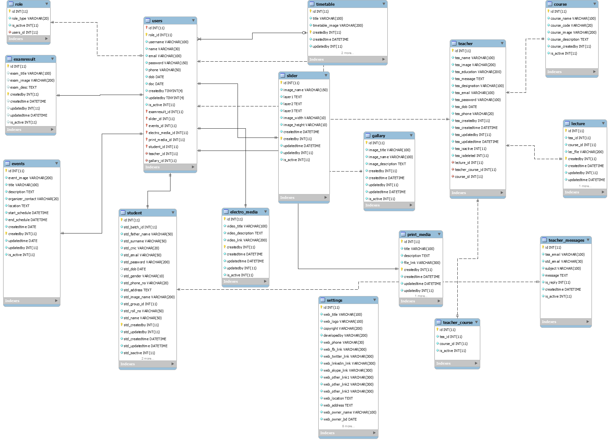

Figure 3‑7: Entity Relationship Diagram

## SYSTEM ARCHIECTURE

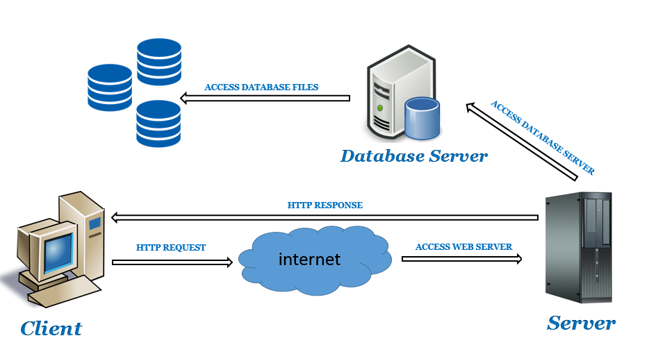

Figure 3‑8: System Architecture

# TOOL & TECHNOLOGIES

## OVERVIEW OF TOOLS

A software development tool is program or application that software developers use to create debug, maintain, or otherwise support other programs and applications. The term usually refers to relatively simple programs that can be combined together to accomplish a task, much as one might use multiple hand to fix a physical object.

The history of software tools began with first computers in the early 1950s that used linkers, loader, and control program. Tools became famous with UNIX in the early 1970s with tools like grep, awk and make that meant to be combined flexibly with pipes. The term “software tools” came the book of the name by brain Kernighan and P. J. Plauger.

Tools were originally simple and light weight. As some tools have been maintained, they have been integrated into more powerful integrated Development Environments (IDEs). These environments consolidate functionality into one place, sometime increasing simplicity and productivity, other times sacrificing flexibility and extensibility. The workflow of IDEs is routinely contrasted with alternative approaches, such as the use of UNIX shell tools with text editors like Vim and Emacs.

The distinction between tools applications is murky. For example, developers use simple databases (such as a file containing a list of important values) all the time as tools. However, a full-blown database is database is usually thought of as an application in its own right.

For many years, computer Assisted Software Engineering (CASE) tools were sought after. Successful tools have proven elusive. In one sense, CASE tools emphasized design and architecture support, such as for UML. But the most successful of these tools are IDEs.[6]

## HTML/CSS

HTML (Hypertext Markup Language) is the set of markup symbols or codes inserted in a file intended for display on a World Wide Web browser page. The markup tells the Web browser how to display a Web page's words and images for the user.

HTML defines the structure and layout of a Web document by using a variety of tags and attributes.

HTML language, called tags are words surrounded by brackets. HTML tags are written as pairs, there must be a beginning tag and an ending tag in order to make the code display correctly. The firs tag designates how the following text will be grouped or displayed, and the closing tag (with a backslash) designates the end of this group or display.

The correct structure for an HTML document starts with,

<HTML><HEAD> (enter here what document is about)

<BODY>

All the information you'd like to include in your Web page fits in between these tags.

</BODY>

</HTML>

### HTML5

HTML5 is the latest version of Hypertext Markup Language, the code that describes web pages. It's actually three kinds of code: HTML, which provides the structure; Cascading Style Sheets (CSS), which take care of presentation; and JavaScript, which makes things happen. One of the design goals for HTML5 is to support for multimedia on mobile devices.

### Cascading Style Sheets (CSS)

**Cascading Style Sheets (CSS)** is a style sheet language used for describing the presentation of a document written in a markup language. CSS describes how HTML elements are to be displayed on screen, paper, or in other media. CSS saves a lot of work. It can control the layout of multiple web pages all at once. External style sheets are stored in CSS files.CSS gives more control over the appearance of a Web page to the page creator than to the browser designer or the viewer. With CSS, the sources of style definition for a given document element are in this order of precedence:

1. The STYLE attribute on an individual element tag
2. The STYLE element that defines a specific style sheet containing style declarations or a LINK element that links to a separate document containing the STYLE element. In a Web page, the STYLE element is placed between the TITLE statement and the BODY statement. [7]

## PHP

PHP (Personal Home Page/ Hyper Text Pre-Processor) is a programming language that is designed for building a variety of web applications that run on the Windows operating system and as well as Linux. Php is simple, powerful, type-safe, and object-oriented. The many innovations in php enable rapid web application development while retaining the expressiveness and elegance of C-style languages.

Php is server side scripting language for web development but also used as a general-purpose programming language use for enhance the web pages. In HTML and PHP code can easily be embedded. PHP is compatible with various platforms like windows, Mac, OS X etc

### USAGE PHP SCRIPT

Three main areas where PHP scripts are used:

* Server-side scripting
* Command line scripting
* Writing desktop applications

### ADVANTAGES OF PHP

* Open source
* Simple and very easy to learn.
* Support for both structural programming and Object Oriented Programming.
* Powerful library support
* Built-in database connection modules
* PHP also has support services using protocols such as LDAP, IMAP, SNMP, NNTP, POP2, HTTP, COM (on Windows)
* Easy deployment and cost effective hosting. [8]

### APACHE SERVER

Apache is the most widely used web server software. Developed and maintained by Apache Software Foundation, Apache is an open source software available for free. It runs on 67% of all web servers in the world. It is fast, reliable, and secure. It can be highly customized to meet the needs of many different environments by using extensions and modules.

* **APACHE VERSION 3.2.1**

The Apache Software Foundation and The Apache HTTP Server Project are pleased to announce the release of version 3.2.1 of the Apache HTTP Server(“Apache”).

This version of Apache is principally a bug and security fix release. [9]

## JAVA SCRIPT

JavaScript is a programming language used to make web pages interactive. It runs on your visitor's computer and doesn't require constant downloads from your website. JavaScript is a cross-platform, object-oriented scripting language. JavaScript contains a standard library of objects, such as Array, Date, and Math, and a core set of language elements such as operators, control structures, and statements.

* Client-side JavaScript extends the core language by supplying objects to control a browser and its Document Object Model (DOM).
* Server-side JavaScript extends the core language by supplying objects relevant to running JavaScript on a server.

JavaScript is used in Web site development to do such things as:

* Automatically change a formatted date on a Web page
* Cause a linked-to page to appear in a popup window
* Cause text or a graphic image to change during a [mouse](http://searchexchange.techtarget.com/definition/mouse) [rollover](http://whatis.techtarget.com/definition/rollover) [10]

## JQUERY

JQuery is the features rich JavaScript library use to simplify the client side scripting of html. JQuery is the most popular library of JavaScript library use in today. JQuery is free, open source software, licensed under the MIT License. Query is ised to make it user to navigate a document, Select the document object model, create animation, handle events and develop the ajax applications. The jQuery library modular approach allows the creation of dynamic web pages and web application. [11]

## BOOTSTRAP

Bootstrap is the most popular HTML, CSS, and JS framework for developing responsive, mobile first projects on the web. Bootstrap is an open-source Javascript framework. It is a combination of HTML, CSS, and Javascript code designed to help build user interface components. Bootstrap was also programmed to support both HTML5 and CSS3.

Also, it is called Front-end-framework.

Bootstrap is a free collection of tools for creating a websites and web applications.

It contains HTML and CSS-based design templates for typography, forms, buttons, navigation and other interface components, as well as optional JavaScript extensions. [8]

Bootstrap can be boiled down to three main files:

* [bootstrap.css](https://github.com/twbs/bootstrap/blob/master/dist/css/bootstrap.css) – a CSS framework
* [bootstrap.js](https://github.com/twbs/bootstrap/blob/master/dist/js/bootstrap.js) – a JavaScript/JQuery framework
* [glyphicons](http://getbootstrap.com/components/#glyphicons) – a font (an icon font set)

### BOOTSTRAP V3.3.5

Use the component and classes of bootstrap.

* **BOOTSTRAP COMPONENTS**

Components built to provide buttons, dropdowns, input groups, navigation, alerts, and much more. [9]

* **BOOTSTRAP CLASSES**

1. **.container**

Sets fixed width to an element (which changes depending on a screen size to other fixed values, so it's still responsive) on all screen sizes except xs - on xs, the width is calculated automatically (this behavior can be changed).

1. **.container-fluid**

Sets 100% width, margin-left and margin-right: auto, padding-left and padding-right: 15px.

1. **.row**

Creates horizontal groups of columns (which usually have width classes, see below).

### BOOTSTRAP FORM’S CLASSES

1. .form-group
2. .form-control
3. .form-control-static
4. .glyphicon
5. .clearfix

**Link: (http://getbootstrap.com)**

### REASONS TO CHOOSE BOOTSTRAP FRAMEWORK

Some Reasons for programmers preferred Bootstrap Framework.

1. Easy to get started
2. Great grid system
3. Base styling for most HTML elements (Typography, Code, Tables, Forms, Buttons, Images, Icons)
4. Extensive list of components
5. Bundled JavaScript plugins. [12]

## MYSQL

MySql is a combination of "My", the name of co-founder Michael Widenius' daughter, and "SQL", the abbreviation for Structured Query Language. MySql is a database system used on the web. Basically, a MySQL database allows you to create a relational database structure on a web-server somewhere in order to store data or automate procedures. Mysql is a open source relational database management system. It runs as a server and allow the multiple user to create numerous database. [13]

## CODEIGNITER

Codeigniter is a php framework created by EllisLab on February 28, 2006 and is now a project of the British Columbia Institute of Technology. codeigniter is built for developer who need an elegant toolkit for web application which is rich of featured. Codeigniter is based on popular development pattern MVC (Model View Controller). In codeigniter the controller classes are necessary where as models and views are optional. Codeigniter is noted for its speed when compared to another PHP framework. To create the website of Mass Communication website we use the **Codeignitor version 3.1**.2. [14]

## NET BEANS

Net Beans is a Platform for software development which is written on java but it is also support other languages such as PHP, C, C++ and HTML5. Net Beans allows application to be developed from modules. Desktop, mobile and web applications can easily be developed by Net Bean. The Net Bean IDE provides set of tools for c, c++ and PHP developers. It is free and open source and has a large community of developers and users. A IDE is much more than a text editor. The Net Bean IDE match the brackets and words, high light the source code and indents lines. Through the Net Beans IDE code can easily be refactor.

### NETBEANS VERSION 8.2

NetBeans IDE 8.2 provides out-of-the-box code analyzers and editors for working. NetBeans IDE 8.2 is available in English, Brazilian Portuguese, Japanese, Russian, and Simplified Chinese.

### NETBEANS IDE BUNDLE FOR PHP

The Net Beans supports the PHP. The bundle for PHP includes:

* PHP code debugging with Xdebugg.
* Code Coverage.
* Syntax highlighting, code completion, occurrence highlighting, error highlighting, CVS version control.
* Semantic analysis with highlighting of parameters and unused local variables.
* Symfony framework support (since version 6.8).
* Zend Framework support (since version 6.9).
* Yii Framework support (since version 7.3).
* PHP 5.3 namespace and closure support (since version 6.8). [15]

# IMPLEMENTATION

## IMPLEMENTATION OF THE DYNAMIC INTERFACE OF MEDIA & COMMUNICATION

### LOGIN OF ADMIN

Below is the login page of Admin. For login to this admin need to provide username and password.

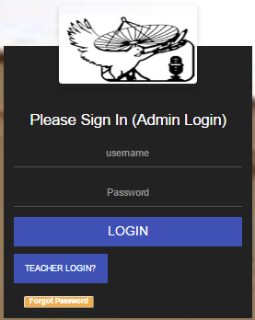

Figure 5‑1: Login of Admin

### ADMIN PANEL

Below is the snapshot of admin panel where Admin

* can add students and teachers
* create events
* manage user accounts
* upload results
* Manage notice board information
* Check enquiry
* 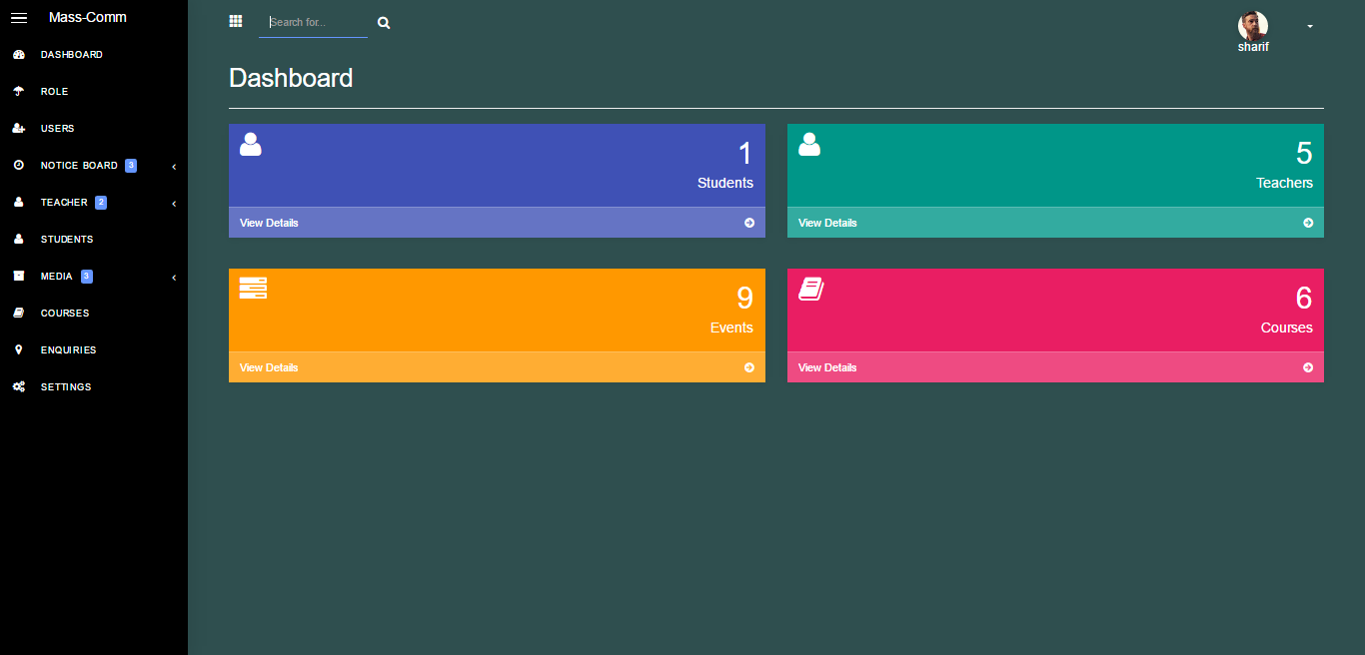Control all setting related to website

Figure 5‑2: Admin Panel

### TEACHER LOGIN

Below is the login page of Teacher. For login to this teacher need to provide username and password.

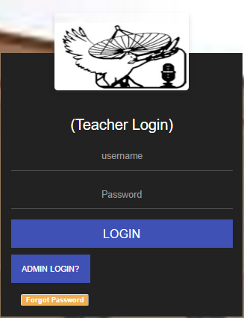

Figure 5‑3: Teacher Login

### LECTURES UPLOAD BY TEACHER

Below is the snapshot of the page where teacher can

* Upload and delete the lectures
* Upload and delete the assignment

### 

Figure 5‑4: Lecture Upload by teacher

### ENQUIRY CHECKED BY TEACHER

This is a page where all enquiries send by students are checked by teacher.

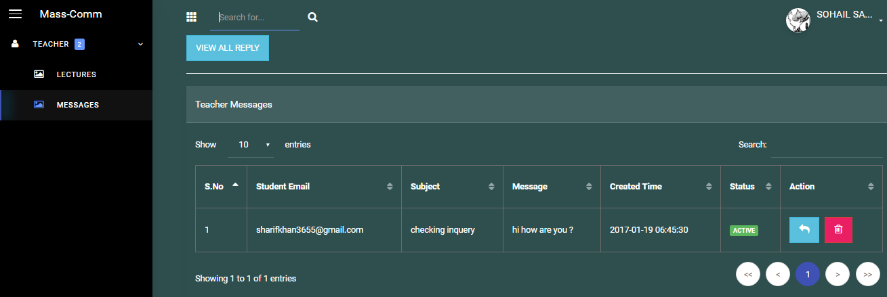

Figure 5‑5: Enquiry Checked by Teacher

### STUDENT REGISTRATION

Below is the registration page of Students. For login to this website student need to provide full name, father name, cnic, email, roll number and phone number.

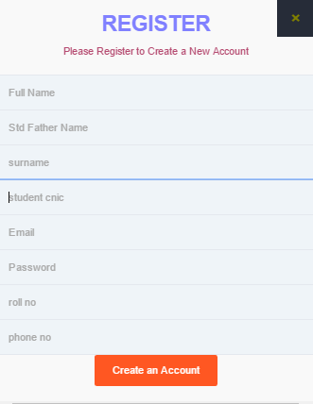

Figure 5‑6: Student Registration

### STUDENT LOGIN

Below is the login page of Students. For login to this student need to provide username and password.

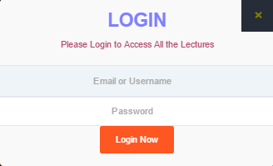

Figure 5‑7: Student Login

### MAIN PAGE

This is the main page of Dynamic Web Interface Of Media and Communication.

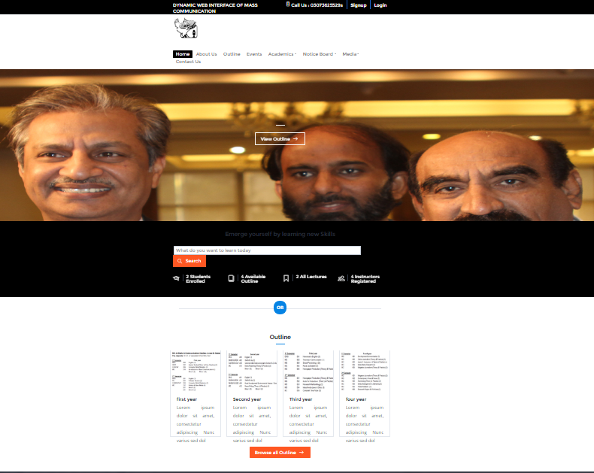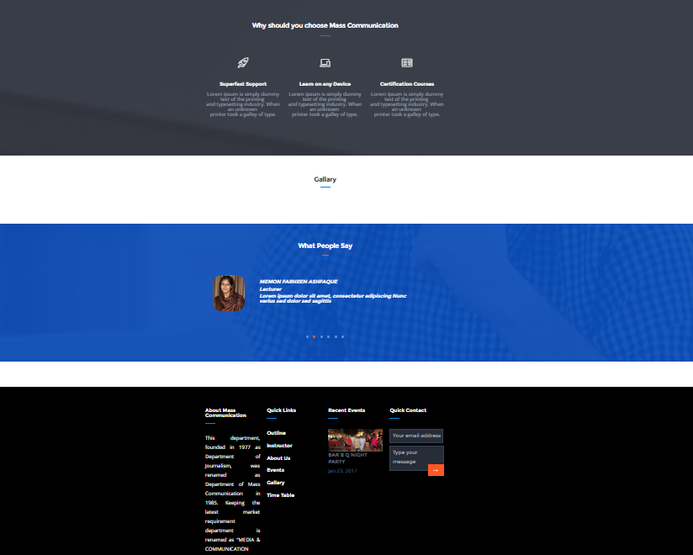

Figure 5‑8: Main Page

### ENQUIRY SEND BY STUDENT

User can send the enquiry to the admin.

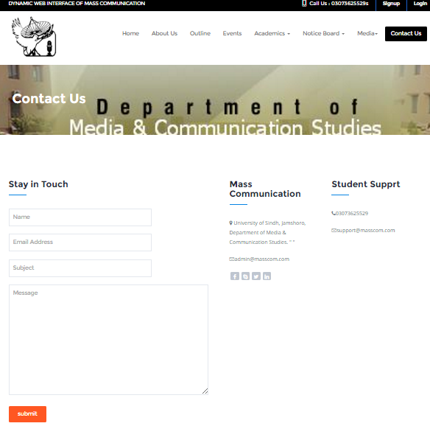

Figure 5‑9: Enquiry Send By Student

### ENQUIRY CHECK BY ADMIN

This is a page where all enquiries send by students are checked by admin.

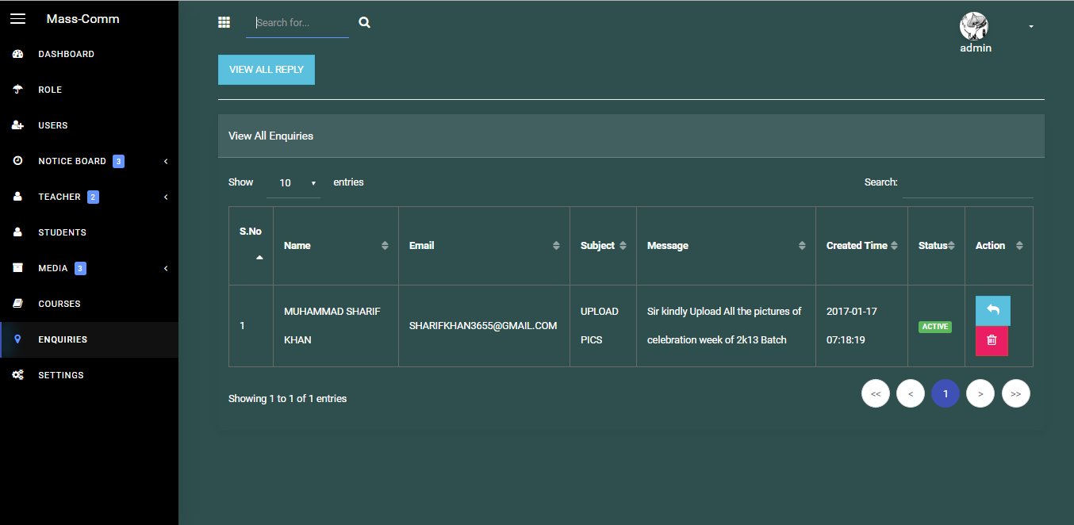

Figure 5‑10: Enquiry Check By Admin

### TIME TABLE UPLOAD BY ADMIN

Below is the snapshot where admin can

* Upload the time table
* Delete the time table
* Active / Pending the time table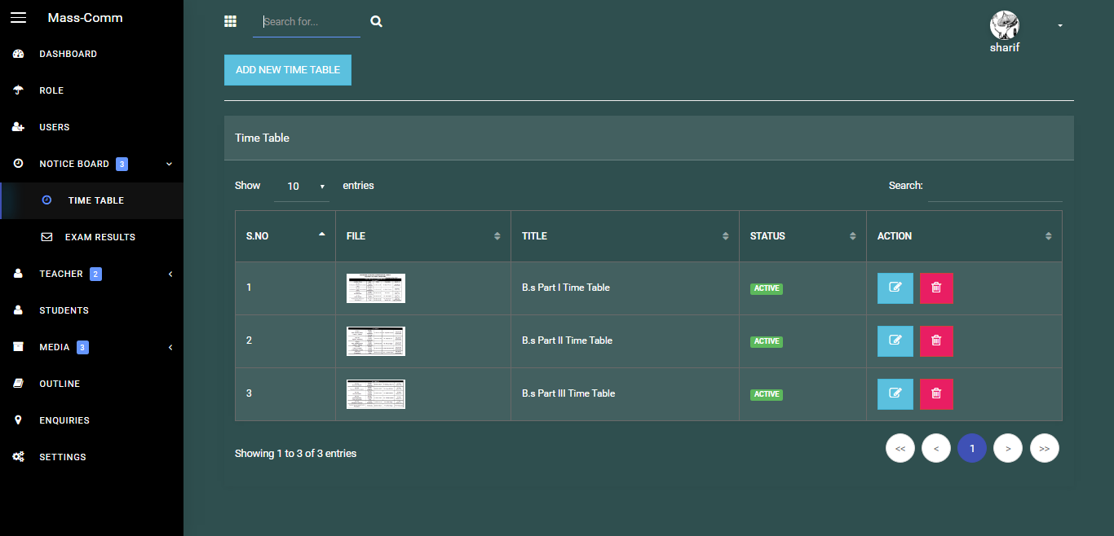

Figure 5‑11: Time Table Upload By Admin

### TIME TABLE DISPLAY AT MAIN PAGE

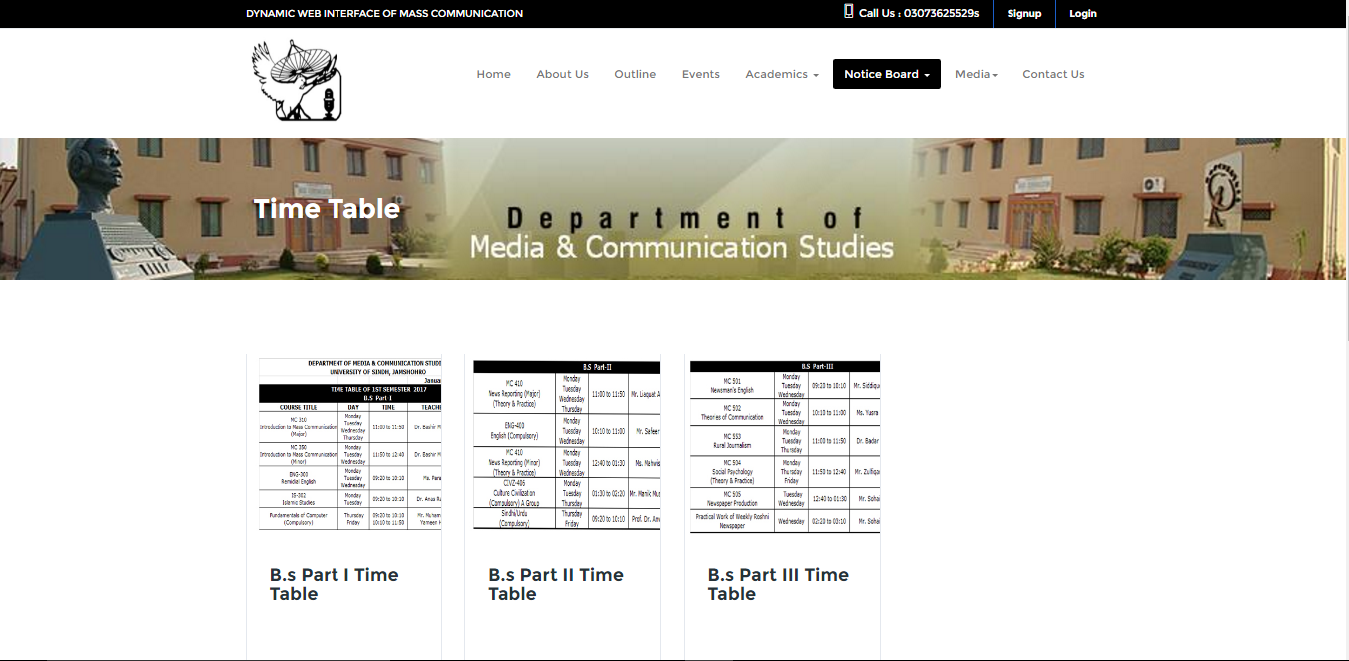Users can see the time table on main page by clicking on notice board option and choose the time table.

Figure 5‑12: Time Table Display at Main Page

### RESULT UPLOAD BY ADMIN

Below is the snapshot where admin can

* Upload the result
* Delete the result
* Active / Pending the result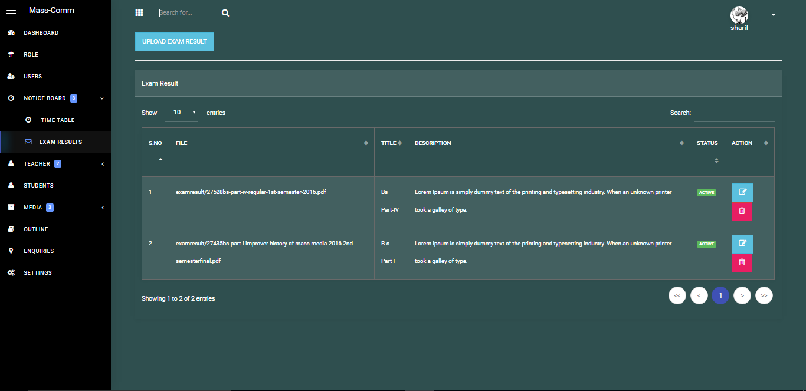

Figure 5‑13: Result Upload by Admin

### RESULT SHOW AT MAIN PAGE

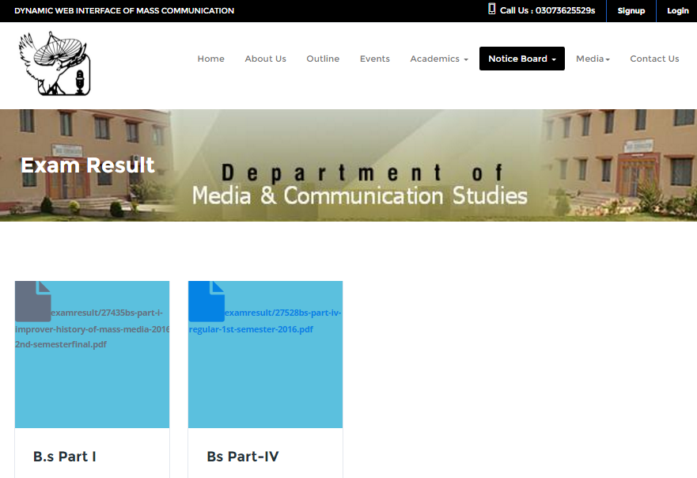Below is the snapshot of page where students can see or download the result in pdf file.

Figure 5‑14: Result show at Main Page

### GALLERY

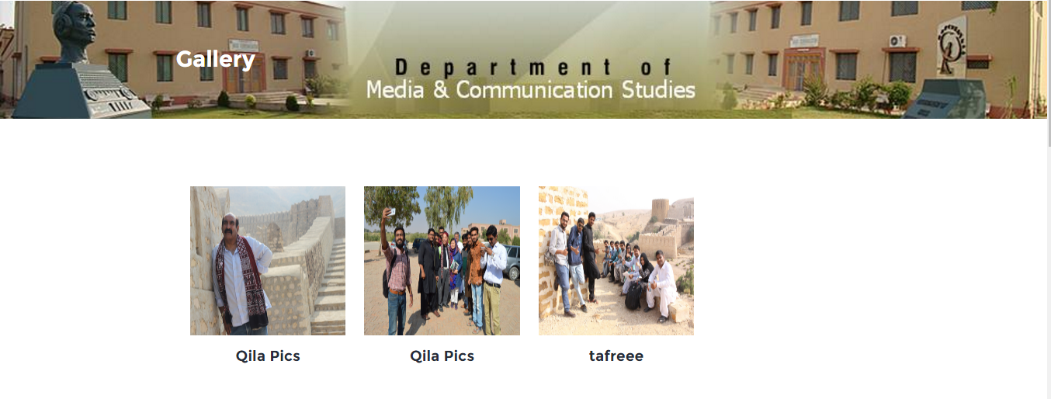Below is the snapshot of gallery page of Dynamic Web Interface of Media and Communication.

Figure 5‑15: Gallery

# RESULTS AND CONCLUSION

## RESULT

It can be said that the required goal has been achieved. Goal was to build a website that can work fully dynamic and perform all the operations of the institute. Where various announcement, Reports, Objectives, Events and Results much soon could be carried out respectively. Using different technologies for this purpose, like *content* management system for Department of Media and Communication Studies has been designed and implemented. This can work on single machine and as well as on local Area Network. Because of this, users have given chance to get information from one place instead of going different sites for same types of information.

## CONCLUSION

The internet has become a major resource just not in Education but in every field of life, thus the website of Department of Media and Communication Studies has gained significance not only from the presentation of site in best way but also in the student’s point of view. Hence, we have designed the project to provide the user with easy navigation, retrieval of data and necessary feedback as must as possible.

A good website must be accompanied with user-friendly interface. It should convenient for the user to view the content of their interest and to be able to fulfill their requirements. The website describes in this project provide the number of features. Those are designed to make the user more comfortable at their Comfort ends.

The project helps in understanding the creation of an interactive webpage and the technologies use to implement it. the building of this project has given us prestigious knowledge about how PHP is used to develop a website, how connects to the database to across the data, and how the data and Webpages are modified to provide the user with particular application interactive.

## FUTURE RECOMMENDATION

The web site of Department of Media and Communication Studies can be enhanced In the future. However, the time is very short and in little time period we tried our best to make the project perfect and used the expertise in each line of code to reach the peak of success. There are some limitations for the current system to which solution can be provided as future development by Administrator, if would be implementation for the respected Department of Media and Communication Studies University of Sindh.

* In future, an android application can be developed for the purpose of accessing information everywhere and anytime. As today is the Era of mobile apps. So, we can convert it into mobile application with different platforms such as Fonegap, Ionic, IOS and etc. It will give more functionality to DYNAMIC INTERCAE OF MASS COMMUNICATION. For this purpose, user should have android phone.
* Some more features can be added such as attendance system can be connected which will generate student’s monthly attendance in percentage.
* Another feature that is result alert via SMS can be added through which user can be notified about results on his/her phone by providing his/her details by SMS.
* Online chatting with audio and voice can be implemented in future.
* We can also give access to parents of the children where all the parents have knowledge of children’s progress of the month or whole semester. They also get their children progress on mobile through SMS.
* Video conferencing can be added for the students involved in group projects/ assignments.
* Online assignment submission can be connected with this system.

# REFERENCES

[1] “Introduction of Website” [Online] Available: https://en.wikipedia.org/wiki/Website

[2] “Static and Dynamic Websites” [Online] Available: http://www.spiderwriting.co.uk/static-dynamic.php

[3] “Guidelines for Responsive Web Design” [Online] Available: https://www.smashingmagazine.com/2011/01/guidelines-for-responsive-web-design/

[4] “What is Web 2.0” [Online] Available: http://www.aiim.org/What-is-Web-20#

[5] Software Requirement Engineering” [Online] Available: http://ecomputernotes.com/software-engineering/softwarerequirement

[6] “Introduction to Software Engineering Tools” [Online] Available: https://en.wikibooks.org/wiki/Introduction_to_Software_Engineering/Tools

[7] “About HTML and CSS” [Online] Available: https://www.w3.org/standards/webdesign/htmlcss

[8] “About PHP” [Online] Available: https://en.wikipedia.org/wiki/PHP

[9] “About Apache Server” [Online] Available: http://www.wpbeginner.com/glossary/apache/

[10] “Java Script Tutorial” [Online] Available: https://www.tutorialspoint.com/javascript/javascript_overview.htm

[11] “JQuery” [Online] Available: https://en.wikipedia.org/wiki/JQuery

[12] “What is Bootstrap and how do I use it” [Online] Available: https://www.taniarascia.com/what-is-bootstrap-and-how-do-i-use-it/

[13] “MySQL” [Online] Available: https://en.wikipedia.org/wiki/MySQL

[14] “Introduction to Codeigniter” [Online] Available: https://www.sitepoint.com/an-introduction-to-codeigniter/

[15] “Netbeans” [Online] Available: https://en.wikipedia.org/wiki/NetBeans